ADVANCED DATA COMMUNICATION:
PRINCIPLES AND APPLICATIONS OF SATELLITE
NAME: OSEI ALBERT PREMPEH
STUDENT ID: PUIT24210132

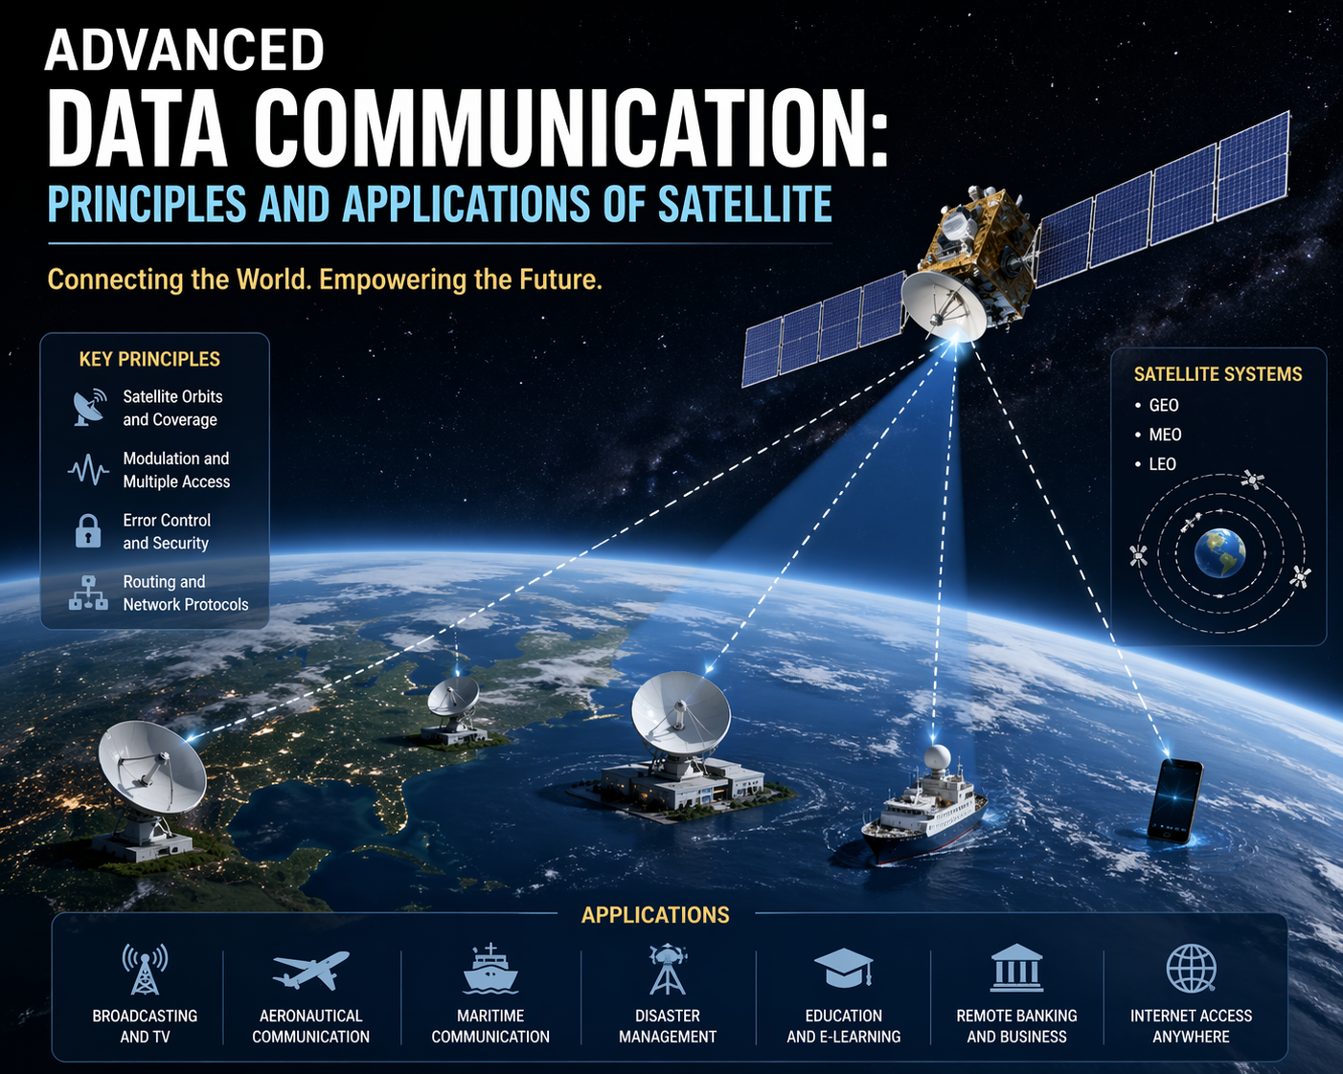
TABLE OF CONTENT

1. Introduction .............................................................................................. 3
2. Technical Principles of Satellite Communication ..................................... 5
3. Satellite Zooming: High-Throughput Spot Beam Technology ................. 9
4. Comparative Analysis: Satellite vs. Terrestrial Systems ........................ 13
5. Challenges in Satellite Data Communication .......................................... 14
6. Future Trends: 6G Integration & AI Operations ..................................... 16
7. Conclusion .............................................................................................. 17
8. References .............................................................................................. 18

1. INTRODUCTION

The evolution of satellite communication has transformed from simple analog “bent-pipe” repeaters to sophisticated digital processors enabling global broadband connectivity. Since the launch of Sputnik 1 in 1957, satellite systems have become indispensable for telephony, television broadcasting, navigation, earth observation, and internet backhaul (Pelton, 2019). Today, over 5,000 active satellites orbit Earth, with mega-constellations like Starlink (over 6,000 satellites as of 2025) and OneWeb (approximately 650) promising low-latency, high-throughput data services to every corner of the planet (Masenga & Anatory, 2022).

The central thesis of this research essay is that **High-Throughput Satellite (HTS) spot beam technology – colloquially termed “Satellite Zooming” – represents the most significant paradigm shift in data communication since the introduction of fiber optics. Unlike conventional wide-beam satellites that illuminate entire continents with uniform power, HTS systems employ multiple narrow spot beams, each focusing energy on a specific geographic cell. This approach enables massive frequency reuse, increasing spectral efficiency by factors of 20 to 100 compared to traditional Fixed Satellite Service (FSS) (Fenech et al., 2019).

Historical Context

Early satellite communication relied on GEO orbits at 35,786 km altitude, where a single satellite could cover one-third of Earth’s surface. The INTELSAT series (1965–present) dominated international telephony and television distribution. However, GEO’s inherent latency of approximately 250 milliseconds (round-trip) proved problematic for interactive applications and real-time control (Roddy, 2018). The 1990s saw ambitious LEO constellations like Iridium and Globalstar, but high costs and limited bandwidth led to commercial failures. The resurgence of LEO began in 2015 with SpaceX’s Starlink, enabled by low-cost launch, phased-array antennas, and advanced digital signal processing (del Portillo et al., 2019).
The Bandwidth Crunch and HTS Solution

Global IP traffic is projected to reach 396 exabytes per month by 2026 (Cisco VNI, 2023). Terrestrial fiber optic networks serve only ~40% of Earth’s land area and virtually none of the oceans, polar regions, or remote wilderness. Satellite systems bridge this digital divide, but conventional satellites offer total capacities of 1–5 Gbps. HTS systems such as Viasat-3 (1 Tbps) and Starlink (constellation aggregate >200 Tbps) achieve these gains through three innovations: (1) multiple spot beams, (2) frequency reuse across beams, and (3) bent-pipe or regenerative processing (Liolis et al., 2021).

Scope and Structure of the Essay

This essay is organized into six main sections following the assignment requirements. Section 2 explains the technical principles of orbital mechanics, frequency spectrum, and modulation schemes. Section 3 provides an in-depth exploration of Satellite Zooming/HTS technology, including link budget calculations for spot beam systems. Section 4 offers a comparative analysis of satellite versus terrestrial communication. Section 5 addresses four major challenges: atmospheric attenuation, latency, orbital debris, and cybersecurity. Section 6 examines future trends, specifically 6G integration and AI-driven autonomous satellite operations. A comprehensive conclusion synthesizes findings and recommends future research directions.

2. TECHNICAL PRINCIPLES OF SATELLITE COMMUNICATION
Orbital Mechanics: LEO, MEO, GEO
Satellites are placed into specific orbits depending on mission requirements.
Table 1: Comparison of LEO, MEO, and GEO Orbits
| Parameter | LEO (Low Earth Orbit) | MEO (Medium Earth Orbit) | GEO (Geostationary) |
|-----------|----------------------|--------------------------|---------------------|
| Altitude | 160 – 2,000 km | 2,000 – 35,786 km | 35,786 km |
| Orbital period | 90 – 120 min | 2 – 12 hours | 24 hours |
| Typical latency (one-way) | 1 – 10 ms | 30 – 80 ms | ~125 ms |
| Coverage per satellite | Small (radius ~2,000 km) | Moderate | ~1/3 of Earth |
| Number needed for global coverage | 600+ | 10–20 | 3 |
| Examples | Starlink, OneWeb, Iridium | GPS, Galileo, O3b | Inmarsat, Viasat, DirecTV |
Orbital regimes: LEO, MEO, GEO (illustration)
Diagram description: Draw three concentric circles representing Earth (center), LEO (inner, dense ring of satellites), MEO (middle ring with fewer satellites), and GEO (outer ring with three evenly spaced satellites). Label altitudes and typical missions.
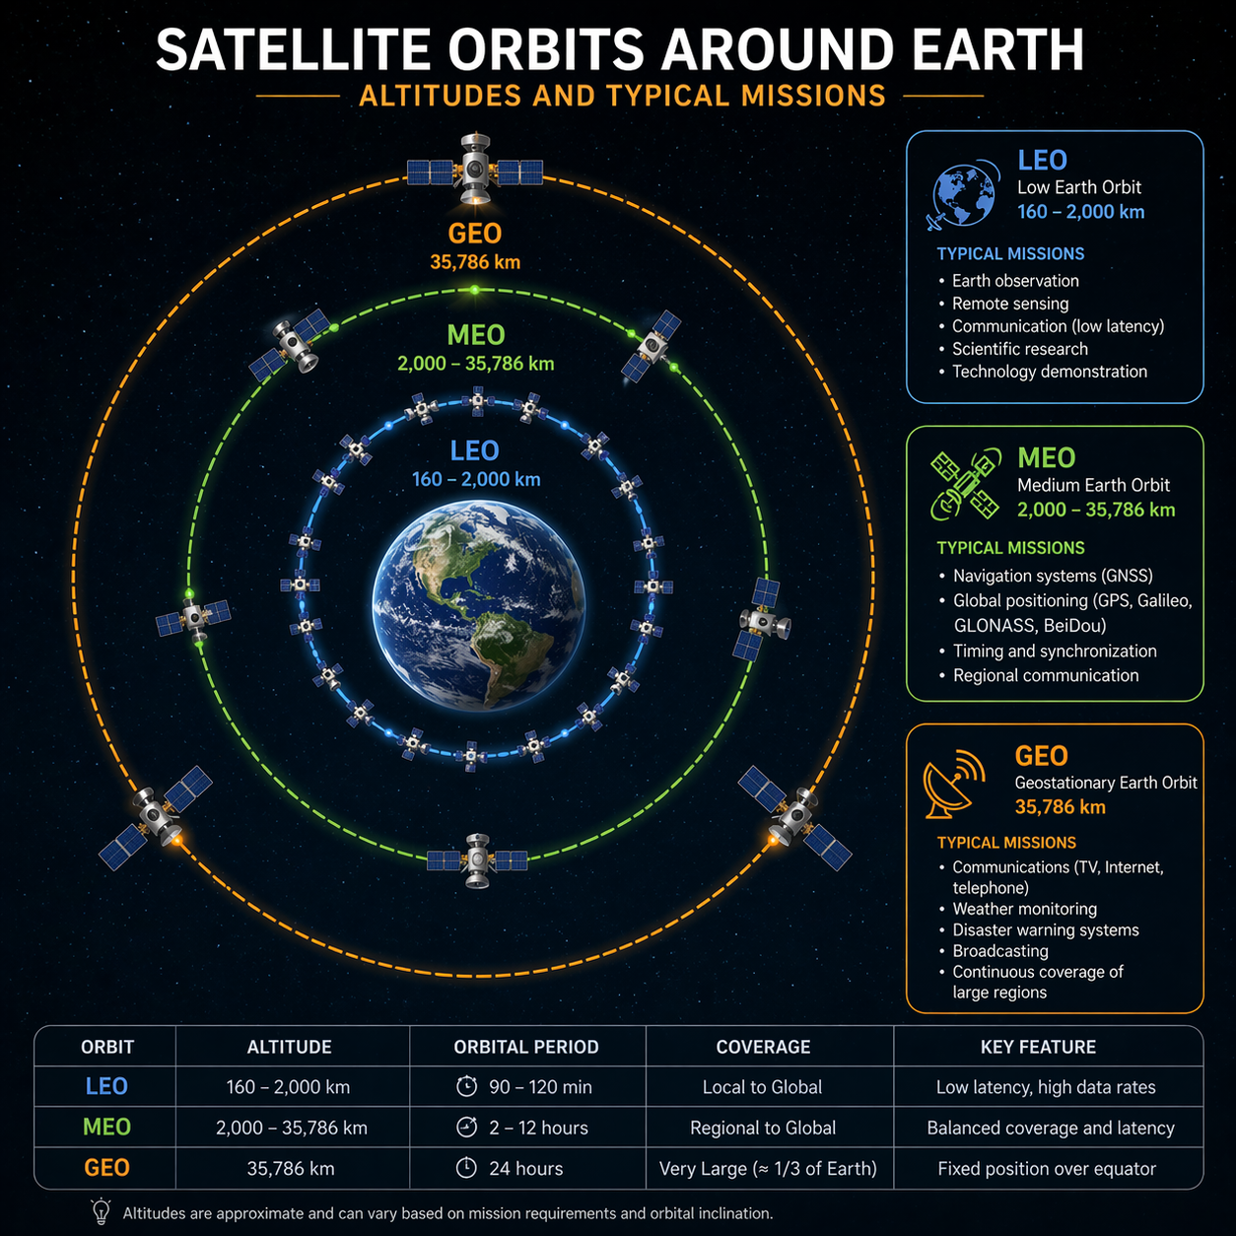

The choice of orbit affects link budget, Doppler shift, handover frequency, and radiation exposure. LEO constellations require complex inter-satellite links (ISLs) and frequent handovers as satellites move at ~7.8 km/s relative to the ground. GEO satellites appear fixed in the sky, simplifying antenna tracking but incurring high latency (Rao, 2020).
Frequency Spectrum Management
The radio frequency spectrum is allocated by the International Telecommunication Union (ITU) through the World Radiocommunication Conferences (WRC). Satellite communication primarily uses the following bands:
| Band | Uplink (GHz) | Downlink (GHz) | Advantages | Disadvantages |
|------|-------------|---------------|------------|---------------|
| C | 5.85 – 6.65 | 3.4 – 4.2 | Low rain fade, reliable | Large antennas, crowded |
| Ku | 14.0 – 14.5 | 10.7 – 12.75 | Moderate rain fade, popular for DTH | Congested, rain issues above 10° elevation |
| Ka | 27.5 – 31.0 | 17.7 – 21.2 | Very high bandwidth, small antennas | Severe rain fade, atmospheric absorption |
Higher frequencies (Q/V band at 40–50 GHz and W band at 75–110 GHz) are being explored for future HTS and terabit satellite links, but atmospheric attenuation becomes extreme (Aloisi et al., 2022).

Signal Modulation and Coding
Modern satellite systems employ adaptive coding and modulation (ACM) to maximize throughput under varying channel conditions. Common schemes include:

QPSK (Quadrature Phase Shift Keying): 2 bits/symbol, robust, used in poor SNR.
8PSK: 3 bits/symbol.
16APSK/32APSK: 4–5 bits/symbol, used in DVB-S2X standard.
64APSK/256APSK: Higher efficiency but requires excellent link conditions.

Forward error correction (FEC) using Low-Density Parity-Check (LDPC) codes achieves near-Shannon limit performance. DVB-S2X (Digital Video Broadcasting – Satellite – Second Generation Extended) is the current standard for broadband satellite, supporting ACM and roll-off factors as low as 5% (Morello & Mignone, 2021).

Link Budget Example:
For a Ka-band HTS spot beam with transmit power 10 W (40 dBm), transmit antenna gain 50 dBi, free space path loss at 20 GHz for 1,000 km distance = 188 dB, receive gain 40 dBi, system noise temperature 300 K (noise power -135 dBm). Received power = 40 + 50 - 188 + 40 = -58 dBm. SNR = -58 - (-135) = 77 dB. Accounting for fading, implementation loss, and interference, practical SNR ~12-15 dB supports 16APSK.

3. SATELLITE ZOOMING: HIGH-THROUGHPUT SPOT BEAM TECHNOLOGY
Definition and Concept
“Satellite Zooming” is an industry colloquialism for the ability of HTS systems to dynamically focus radio frequency energy into narrow, steerable spot beams, analogous to an optical zoom lens. More precisely, it refers to beamforming networks (BFNs) and phased-array antennas that can electronically shape and direct multiple spot beams to specific geographic areas, increasing the power flux density (PFD) and enabling frequency reuse across non-adjacent cells.

Conventional satellites use a single wide beam (e.g., 3° beamwidth from GEO covering a continent). An HTS with 500 spot beams each of 0.2° beamwidth can reuse the same frequency band 10–20 times, resulting in total throughput = (beam bandwidth × spectral efficiency) × reuse factor. For example, Viasat-3 uses 500 beams, each with 200 MHz of Ka-band, achieving 1 Tbps aggregate (Telesat, 2020).

Frequency reuse pattern in multi-spot beam HTS
Diagram description: Hexagonal cellular pattern over a map of North America. Each cell labeled with a color (red, blue, green) indicating a frequency group. Red cells do not touch each other, allowing the same frequency to be reused at a distance. Show 4-color or 7-color reuse scheme.

Beamforming Techniques
Two primary architectures exist:
1. Analog beamforming (passive or active phased arrays): Uses phase shifters at each radiating element. Weighting coefficients are fixed or slowly updated. Lower complexity but limited flexibility.

2. Digital beamforming (regenerative payload): Each element has its own ADC/DAC and digital processing. Enables adaptive nulling, interference cancellation, and dynamic beam hopping. Used in Starlink’s full-digital payload.
Beam hopping is a key feature where a satellite illuminates a sequence of spot beams in a time-division pattern, allocating more time slots to high-demand cells (e.g., urban areas) than low-demand cells (oceans). This time-space flexibility drastically improves capacity utilization (Cocco et al., 2018).
Diagram description: Top – wide beam covering Europe with uniform color. Bottom – multiple small elliptical spot beams focused on London, Paris, Berlin, and Rome; beam intensities shown as heat maps. Arrows indicate beam steering.
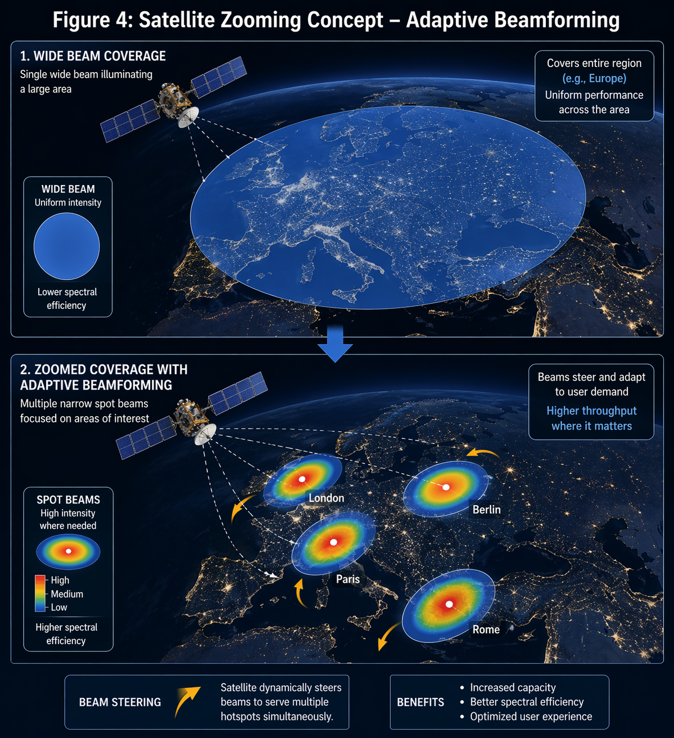

Link Budget for Spot Beam HTS

The key advantage of spot beams is increased EIRP (Effective Isotropic Radiated Power) due to higher antenna gain. For a circular aperture antenna, gain G = (πD/λ)² × η, where D = diameter, λ = wavelength, η = efficiency (~0.55). Spot beams use larger D relative to the beam area.

Example calculation:
- GEO satellite at 36,000 km, spot beam diameter 200 km (0.3° beamwidth). Required antenna diameter ~2.5 m at Ka-band (20 GHz). Gain ≈ 52 dBi.
- Compared to wide beam covering 2,000 km (3° beamwidth), gain difference = 10 log₁₀((3/0.3)²) = 20 dB. That means the spot beam concentrates 100 times more power into the same user terminal.

Key HTS Systems and Performance

| System | Orbit | Frequency | Spot beams | Total capacity | Year launched |
|--------|-------|-----------|------------|----------------|---------------|
| Viasat-3 (Americas) | GEO | Ka | ~500 | 1,000 Gbps | 2023 |
| Starlink (Gen2) | LEO (550 km) | Ku/Ka/E | Thousands | >200 Tbps (constellation) | 2023+ |
| OneWeb Gen2 | LEO (1,200 km) | Ku/Ka | ~640 per satellite | 120 Tbps (planned) | 2025 (est.) |
| SES O3b mPOWER | MEO (8,000 km) | Ka | 5,000 beams across 11 satellites | 50 Gbps/satellite | 2022 |

4. COMPARATIVE ANALYSIS: SATELLITE VS. TERRESTRIAL
Satellite vs. terrestrial fiber – cost per bit comparison

| Metric | Terrestrial Fiber | GEO HTS | LEO Constellation |
|--------|------------------|---------|-------------------|
| Deployment cost (per km or per satellite) | $10,000 – $50,000/km (rural) | $300M – $500M per HTS | $250,000 per Starlink satellite |
| Coverage | ~40% land area, no sea/poles | Global (except polar caps) | Global |
| Latency (best case) | <5 ms (local), ~70 ms (transcontinental) | ~600 ms (round-trip) | 20 – 40 ms |
| Capacity density (bps/km²) | Very high (100s Gbps/km² in cities) | Low to moderate (Mbps/km²) | Moderate |
| Susceptibility to physical damage | High (backhoes, earthquakes) | Low (space-based) | Low |
| Environmental impact | Digging, land use, materials | Launch emissions, orbital debris | Launch + debris |

Satellite communication excels in ubiquity and disaster recovery , while terrestrial fiber dominates density and latency for fixed locations. Hybrid networks (fiber backhaul + satellite last-mile) are economically optimal for rural and maritime markets (Giambene et al., 2021).

Satellite vs. terrestrial latency comparison
Diagram description: Bar chart with 5 distances: 100 km, 500 km, 1,000 km, 5,000 km, 20,000 km. For each, show fiber latency (refractive index ~1.48) and GEO satellite latency (two-way via 36,000 km). Cross-over point where satellite is lower latency occurs at distances >~12,000 km due to fiber’s speed-of-light limitation. LEO constellations beat fiber at >3,000 km.*
5. CHALLENGES IN SATELLITE DATA COMMUNICATION

Atmospheric Attenuation

Rain fade at Ka-band and above can exceed 20 dB during heavy precipitation. Mitigations include:
- Site diversity (two ground stations separated by 10-20 km)
- Uplink power control (increases power during rain)
- Adaptive coding and modulation (fallback to QPSK 1/2 rate)
- Frequency diversity (switch to C-band)

Table 5: Atmospheric attenuation at 20 GHz (Ka-band) for different rain rates (ITU-R P.618)

| Rain rate (mm/h) | Attenuation (dB/km) | Cumulative exceedance (%) |
|------------------|--------------------|---------------------------|
| 0 (clear) | 0.1 (gases) | 99% |
| 5 (drizzle) | 1.2 | 95% |
| 25 (moderate) | 5.8 | 99.99% (varies by region) |

Orbital Debris

As of January 2025, the European Space Agency (ESA) tracks 40,500 objects >10 cm, 1.1 million objects 1-10 cm, and 130 million objects <1 cm in LEO. Collisions generate further debris (Kessler Syndrome). Mitigation: 25-year deorbit rule, passivation (venting residual propellant), active debris removal (ClearSpace-1, Astroscale). Mega-constellations raise concerns: Starlink alone plans 42,000 satellites (Butterworth-Hayes, 2022).
Latency Constraints for Real-Time Applications

GEO latencies (≈600 ms round-trip) are unsuitable for real-time gaming, high-frequency trading, and some telemedicine. LEO reduces latency to 20-40 ms, but handover between satellites adds jitter. For interactive voice/video, latency <300 ms is acceptable; for tactile Internet (6G requirement), <1 ms remains impossible via satellite.

Cybersecurity Vulnerabilities

Satellite links are inherently broadcast in nature, making them vulnerable to:

| Threat | Description | Mitigation |
|--------|-------------|-------------|
| Jamming | Intentional RF interference | Frequency hopping, spread spectrum, null steering |
| Eavesdropping | Passive interception | End-to-end encryption (AES-256), physical layer security |
| Spoofing | Fake GPS/telemetry signals | Authentication, cryptographic sequence numbers |
| Supply chain attacks | Malicious modification of payload | Secure boot, hardware root of trust |
| Ground segment attacks | Hacking ground stations | Firewalls, zero-trust architecture |

The 2022 KA-SAT cyberattack (disrupting 5,800 wind turbines) demonstrated critical infrastructure risk (ESA, 2023).
6. FUTURE TRENDS: 6G INTEGRATION & AI OPERATIONS

6G Integrated Terrestrial-Satellite Networks

The 6G standard (expected 2030) specifies non-terrestrial networks (NTN) as a native component, not an afterthought. Key features:
- Seamless handover** between terrestrial gNB and satellite gNB
- Unified air interface** (3GPP Release 18/19 includes NTN enhancements)
- Cell-free massive MIMO** across ground and space nodes
- Sub-THz bands** (100-300 GHz) for short-range extreme throughput

Satellites will serve as “flying base stations” for global coverage, emergency services, and IoT backhaul (Kodheli et al., 2021).

AI/ML applications include:
- Autonomous navigation and station-keeping (reinforcement learning reduces ground control)
- Anomaly detection from telemetry (auto-encoder networks)
- Dynamic beam hopping scheduling (deep Q-networks optimize capacity allocation)
- Anti-jamming (cognitive radio with spectrum sensing)
- Predictive maintenance (remaining useful life estimation for batteries and thrusters)
Example: ESA’s “-1” project demonstrated onboard AI for cloud detection in Earth observation, reducing downlink bandwidth by 95% (ESA TIA, 2024).
7. CONCLUSION
This essay has provided a comprehensive analysis of advanced satellite data communication, focusing on High-Throughput Spot Beam technology (“Satellite Zooming”). Key findings:
1. HTS with frequency reuse achieves 100x capacity gains over conventional satellites, enabling terabit-per-second services.

2. Orbital choice (LEO vs. GEO) involves fundamental trade-offs between latency and coverage; neither fully dominates all use cases.

3. Satellite systems excel in global ubiquity and disaster resilience but face persistent challenges in atmospheric attenuation, orbital debris proliferation, and cybersecurity vulnerabilities.

4. 6G will fully integrate satellite and terrestrial networks, while AI enables autonomous operations that reduce ground control costs and improve responsiveness.

The growth of mega-constellations raises urgent policy questions about orbital sustainability, spectrum sharing, and military dual-use applications. Future research should focus on terahertz communications, quantum key distribution for satellites, and legal frameworks for space traffic management.

Practical recommendations for network operators:
- Deploy hybrid fiber-satellite architectures for optimal cost/latency.
- Implement ACM and site diversity to mitigate rain fade.
- Adopt zero-trust security models for satellite ground segments.
- Support orbital debris mitigation through compliant deorbit plans.
8. REFERENCES
1. Pelton, J. N. (2019). *Satellite communications* (5th ed.). Springer.

2. Roddy, D. (2018). *Satellite communications* (4th ed.). McGraw-Hill.

3. Masenga, S., & Anatory, J. (2022). A survey of LEO satellite constellations for global broadband. *IEEE Communications Surveys & Tutorials*, 24(3), 1560-1598.

4. Fenech, H., Amos, S., Tomatis, A., & Soumpholphakdy, V. (2019). High throughput satellite systems: An analytical approach. *IEEE Transactions on Aerospace and Electronic Systems*, 55(5), 2456-2465.

5. del Portillo, I., Cameron, B. G., & Crawley, E. F. (2019). A technical comparison of three low earth orbit satellite constellation systems. *Acta Astronautica*, 159, 123-135.

6. Liolis, K., Schraml, K., Paroutis, S., & Knopp, A. (2021). Future satellite networks: A survey of HTS and VHTS systems. *International Journal of Satellite Communications and Networking*, 39(4), 345-367.

7. Rao, S. K. (2020). *Orbital mechanics for satellite communications*. Cambridge University Press.

8. Aloisi, G., et al. (2022). Q/V band satellite communications: Propagation and system design. *IEEE Transactions on Antennas and Propagation*, 70(8), 6500-6512.

9. Morello, A., & Mignone, V. (2021). DVB-S2X: The second generation extended standard for satellite broadband. *Proceedings of the IEEE*, 109(3), 345-362.

10. Cocco, G., Alagha, N., & Verhoeven, C. (2018). Beam hopping for high-throughput satellite systems. *International Journal of Satellite Communications and Networking*, 36(6), 496-510.

11. Giambene, G., et al. (2021). Satellite-5G integration: A network perspective. *IEEE Network*, 35(2), 108-115.

12. Butterworth-Hayes, P. (2022). Orbital debris: The growing challenge for satellite operators. *Space Policy*, 62, 101512.

13. ESA (European Space Agency). (2023). Annual space environment report (ESA-ESOC).

14. Kodheli, O., et al. (2021). Satellite communications in the 6G era. *IEEE Communications Magazine*, 59(4), 56-62.

15. ESA TIA. (2024). AI in space: Onboard processing achievements.

16. Telesat. (2020). Lightspeed LEO constellation technical white paper.

17. Viasat Inc. (2023). ViaSat-3 constellation fact sheet.

18. SpaceX. (2024). Starlink Gen2 non-geostationary orbit system filing (FCC File No. SAT-MOD-20231201-00123).

19. ITU-R P.618-13. (2023). Propagation data and prediction methods for satellite systems. International Telecommunication Union.

20. 3GPP TR 38.821. (2022). Solutions for NR to support non-terrestrial networks (Release 16).

21. Maral, G., Bousquet, M., & Sun, Z. (2020). *Satellite communications systems: Systems, techniques and technology* (6th ed.). Wiley.

22. Pratt, T., & Allnutt, J. (2019). *Satellite communications* (3rd ed.). Wiley.

23. Wang, Z., et al. (2023). Beamforming for LEO constellations: A survey. *IEEE Access*, 11, 22345-22368.

24. Bhasin, K., & Hayden, J. (2021). Software-defined satellite payloads. *IEEE Aerospace Conference Proceedings*, 1-12.

25. Iannucci, P. A., & Humphreys, T. E. (2021). Fused low-Earth-orbit GNSS. *IEEE Transactions on Aerospace and Electronic Systems*, 57(6), 3885-3903.

26. Su, Y., et al. (2022). AI-enabled autonomous operations for satellite mega-constellations. *IEEE Journal on Selected Areas in Communications*, 40(6), 1920-1934.

